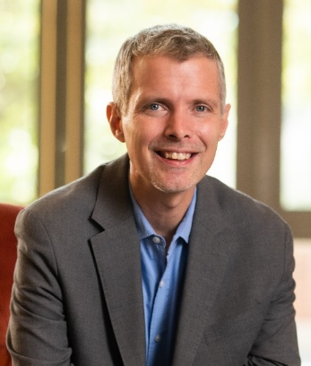
Luke Shaefer
Guest Speaker
H. Luke Shaefer, Ph.D. is the Hermann and Amalie Kohn Professor of Social Justice and Social Policy and Professor of Public Policy at the Gerald R. Ford School of Public Policy at the University of Michigan. At U-M, he is also the inaugural director of Poverty Solutions, an interdisciplinary, presidential initiative that partners with communities and policymakers to find new ways to prevent and alleviate poverty.

Shaefer is one of the nation’s leading scholars of poverty and social welfare policy. His research has been published in top peer-reviewed academic journals in the fields of public policy, public health, health services research, sociology, social work, and history, and his work has been supported by the National Science Foundation, the Bill and Melinda Gates Foundation, and U.S. Census Bureau among other sources. He has presented his research at the White House and before numerous federal agencies, has testified before the U.S. Senate Finance Committee, and has advised a number of the nation’s largest human service providers.

His work has been cited in media outlets such as the New York Times, Washington Post, The Economist, and The Atlantic, and he has been featured on such programs as PBS NewsHour, Marketplace, 1A, All Things Considered, and CNBC’s Nightly Business Report. His book with Kathryn Edin, $2.00 a Day: Living on Almost Nothing in America, was named one of the 100 Notable Books of 2015 by the New York Times Book Review, and won the Hillman Prize for Book Journalism among other awards.

Shaefer’s new co-authored book, The Injustice of Place: Uncovering the Legacy of Poverty in America, has been featured on MSNBC, The Atlantic, TIME, and the LA Times, among other outlets. He is the co-director of Rx Kids, the nation’s first citywide maternal and infant health cash prescription program launched in Flint, Michigan in January 2024. Through Poverty Solutions, Shaefer acted as a special counselor on anti-poverty policy to the director of the Michigan Department of Health and Human Services from 2019-2021.

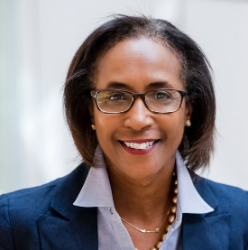
Dona Ponepinto
President and CEO, United Way Pierce County
Dona has been the President and CEO for United Way of Pierce County since 2014 and has been with the United Way movement for more than 30 years. Locally she led a groundbreaking tristate research project on the financial stability of families, deployed navigation specialists for South Sound 211, launched seven Center for Strong Families sites and serves on the Governor’s Poverty Work Group. Currently, in partnership with the City of Tacoma, County and DSHS, she and her team are leading another Guaranteed Income Demonstration project.

Dona has consistently been very engaged in her community and has demonstrated strong leadership through service and board membership. She is a member of the Junior League Tacoma and is a past President of the Association of Junior Leagues International. In addition, she serves on the boards of the Tacoma Art Museum, Wellfound Behavioral Health Hospital, Coordinated Care, and the Workforce Development Council. In 2019, she was appointed by Governor Jay Inslee to serve as a Board of Trustee for Tacoma Community College and is currently chair of the Board. She was recently honored by the University of Washington Milgard School of Business as the 2024 Non-Profit Leader of the Year. Dona holds a BA in Psychology and a MS Degree in Counseling with emphasis in children and families from Creighton University.

Sebrena Chambers, MPA, MBA
Division Director, Strengthening Families, Community Health Division, Tacoma-Pierce County Health Department
She is the current Chair of the United Way of Pierce County Board of Directors and has been a board member for twelve years. She is the Division Director of Special Projects for the for the Tacoma-Pierce County Health Department. Sebrena has been with the health department for twenty-eight years. She was raised in Tacoma and has always been active in her community, serving on many community boards. She fosters trust and collaboration, ensuring all voices are at the table. “Empowering Communities, One Act of Service at a Time.”

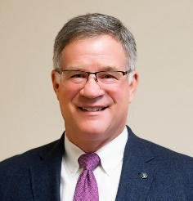
Bruce Dammeier
Pierce County Executive
A Pierce County native, Executive Dammeier attended Curtis High School before going on to graduate with distinction from the U.S. Naval Academy. He served eight years as a Civil Engineer Corps Officer. While on active duty, he was deployed on humanitarian relief missions in the United States and across the world. At the conclusion of his military service, he returned to Washington state, went to work in his family printing business, and became a dedicated community volunteer. Bruce and Lauren, his wife of more than 35 years.

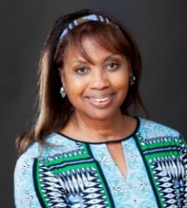
Carol C. Mitchell, J.D.
Founder, Institute for Black Justice
Carol holds a Juris Doctor from Seattle University School of Law, a Master of Arts in Organizational Systems Renewal from Seattle University, and a Bachelor of Arts in Sociology from the University of Washington Seattle. She founded the Institute for Black Justice (IBJ) in September 2020. The purpose of the IBJ is to relentlessly pursue equity and justice for all.

Mitchell has more than 20 years of public sector leadership experience, having served most recently in Pierce County, Washington. Her primary responsibility was to improve outcomes for individuals with behavioral health and substance use conditions who were caught in the grip of the criminal justice system. She has significant organizational and human resources experience, having served for the Port of Tacoma, Metro Parks, Pierce Transit, and as Executive Consultant for her own preventive law firm. Mitchell spent 17 years as the host of TV Tacoma's "CityLine," a public affairs talk show.

Her volunteer activities are endless, she is proud to be in service to her community, to her soon-to-be-88-year-old mother, her 3 adult children and her 6 grandchildren.

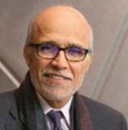
Dr. Ali Modarres
Assistant Chancellor for Community Partnerships at University of Washington Tacoma
Ali is the Assistant Chancellor for Community Partnerships at University of Washington Tacoma. He retired from his position as the Dean of the School of Urban Studies in June 2024. Ali has published in the areas of social geography, immigration, urban development, planning, and policy. A significant portion of his public scholarship focuses on economic development and global labor migration through an equity lens.

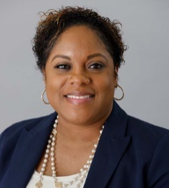
Chantell Harmon Reed
Director of Public Health, Tacoma-Pierce County Health Department
Chantell, a doctoral candidate in public health at Tulane University, is director of public health. An energetic and visionary leader, Reed’s diverse background includes roles in public health, healthcare administration and compliance.

As the deputy director of the Public Health Division of the Multnomah County Health Department in Oregon, Reed supported COVID-19 recovery efforts, infrastructure improvements and achieving accreditation from the Public Health Accreditation Board.

Throughout her career, Reed has helped to close disparity gaps through centering social determinants of health. She honed this approach through various roles with Program for All-Inclusive Care for the Elderly (PACE) of Greater New Orleans.

She also improved operational efficiency in behavioral health care initiatives at JeffCare Community Clinics, a Medicare Certified Federally Qualified Health Center. Her work has improved maternal and infant mortality rates and enhanced the doula workforce.

Reed is committed to community service and has served on many committees and boards, including the New Orleans Regional Leadership Institute, the Loyola Center for Counseling and Education, and the Oregon Public Health Association. Reed has a bachelor’s in business from Northwood University in Cedar Hill, Texas, and a master’s in healthcare management from the University of New Orleans.

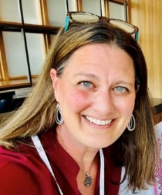
Lindsay Morgan Tracy
Innovator-in-Chief, Economic Services Administration
Washington State Department of Social and Health Services
Lindsay is the Innovator-in-Chief for the Economic Justice Alliance housed in the Department of Social and Health Services in Washington State. She is a staunch advocate of shifting organizational structures from transactional to transformational with an emphasis on continuous learning and stories.

Tracy has expertise in systemic tracking and building capacity and a culture of program improvement for better qualitative and quantitative outcome measures. The work in Washington State centers those who stand to benefit the most from systems-level policy and program shifts to foster long-term solutions for children, families, and communities throughout the state.

Tracy has recently been named one of eight global well-being fellows by the Robert Wood Johnson Foundation. She is a busy mom of two teenage boys, and her family lives on Vashon Island where she is involved in the community, is the oldest team member on her co-ed and ladies league softball teams, and drinks copious amounts of coffee.

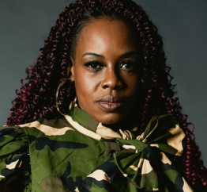
Shellie Willis
Senior Director of Collective Impact, Workforce Central
Shellie is the Senior Director of Collective Impact Workforce Central, the public workforce development council serving employers and job seekers in Tacoma and Pierce County.

Shellie serves as an advocate for system partners and the community by facilitating the Pierce County Community TaskForce and provides education and training on continuous quality improvement opportunities and increases access to education and employment by intentionally working with local elected officials, community partners and employers to solve complex problems in a structured way to design and create and equitable result.

Shellie is also the Founder of “Redefining You Foundation,” a 501© 3 non-profit organization that supports and empowers transitioning service women, women veterans, and military spouses redefine their lifestyles and perspectives following military service. She is a 24-year veteran of the US Army and holds a Master’s Degree in Management- Nonprofit Administration from the University of Maryland, Global Campus.

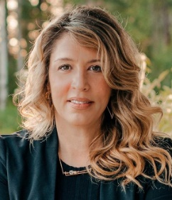
Stacey Crnich
CEO, GoodRoots Northwest
Stacey began her role at the food bank just as the pandemic unfolded, bringing a strategic blend of private sector insight and a passion for community impact. Her leadership draws from private business principles, including marketing strategy, operational efficiency, customer-centric experiences, and technology-driven solutions to meet evolving market needs. GoodRoots Northwest launched the Market and Lockers, an innovative food access model and revolutionary approach inspired by modern retail. This model provides customers with access to fresh, local foods while prioritizing dignity, privacy, and convenience.

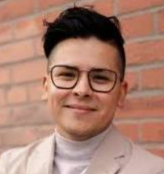
Rafael Saucedo
Philanthropy Program Manager, BECU
From fundraising in the nonprofit sector to leading philanthropic giving initiatives in the credit union space, Rafael’s work has been centered on community and being of service to others. In addition to his professional work experience, Rafael has also earned degrees in Healthcare Leadership and Community Planning from the University of Washington Tacoma, which has provided him with a solid foundation to engage with diverse communities and stakeholders across sectors. Rafael currently helps lead BECU’s philanthropic giving efforts and nonprofit engagement while serving as Chair of BECU’s Latinx Employee Resource Group due to his passion for inclusion and uplifting his Latinx culture. Rafael is a Board Director for the Seattle Southside’s Success Foundation and the Tacoma Community College Foundation. He has previously served on the City of Tacoma’s Immigrant and Refugee Affairs Commission and as Board President of the Tacoma Public Library Foundation. Philanthropy, financial cooperatives, and community building excite Rafael the most, and what keeps him motivated to make change and generate positive impact.

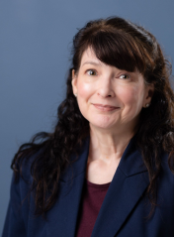
Shawn Paton
VP of Community Impact, United Way Pierce County
Shawn spearheads efforts to unite the community in breaking the cycle of poverty through collaboration with key partners such as the Center for Strong Families, South Sound 211, Growing Resilience in Tacoma (GRIT), and a wide-reaching network of public and private organizations.

A lifelong Pacific Northwesterner, Shawn’s journey with United Way spans 28 years, during which she has made significant strides in advancing the organization's bold goal to move 15,000 households from poverty to self-sufficiency by 2028. With a bachelor’s degree in business management and deep roots in the community, Shawn brings both personal experience and professional expertise to her new position.

Her passion stems from her lived experience as a single mother, having faced the challenges of being an ALICE (Asset Limited, Income Constrained, Employed) household. She intimately understands the struggles many families endure and is driven by a mission to create a community where every family has the opportunity to thrive.

