Jamey McCormick, Presiding

Minutes

Elizabeth Bailey | Amy Eveskcige | Rick Meeder | Dirk Rabdau | Kristen Sawin
Bill Berry | David Graybill | Marilyn Mullenax | Rich Rocks | Jackie Yeh
Tonya Burnett | Tim Holmes | Linda Nguyen | Kent Roberts | Katherine Cavanaugh
Sebrena Chambers | Rod Koon | Jennifer Nino | Brenda Rogers
JoAnne Coy | Matt Levi | David Pearson | Patty Rose
Gerald Denman | Jamey McCormick | Linda Proett | Carla Santorno
UWPC Staff: Dona Ponepinto, Pete Grignon, Sean Armentrout, Ted Smith, Heidi Hansen
Guest: Kari Young

Call to Order/Welcome
Jamey called the meeting to order at 7:30am

Approve Minutes from June 26, 2015
Two correction: In the Presidents Report is should say state funding, not federal money and under Mobile Food Banks, the word “vans” is missing. M/S/C as amended

Financial
Peter and Jennifer gave the financial highlights.
- 2014-15 campaign pledges fell $270K short of our budget forecast but, we will make it up through departmental expenditure savings, over collecting of the 2013 campaign and designations may come in less than anticipated.
- Collections on pledges in the door are 60.44% ahead of the normal range of 0-3% of the prior two years: 58.30% and 56.96%.
- Departmental expenditures under by $195,000; Line items over by $5,000 – None.
- Endowment balance at $3,745,784; $3,290,080 prior year.
- MultiCare has made a lease offer to stay in our building for two years with option for an additional two years.
Standard M
- United Way system standard for deducting resource development and organizational administration expenses from donor designated gifts.
- The fee is based on a three year average of our campaign revenue only and related costs – maximum allowable fee for the coming campaign is 22.50%.
- The calculation excludes “other” revenue: Gifts In Kind, bequests, rental and investment income
- That fee, or a lesser amount can be used.

Past Policy: The cost to charge designated gifts to other nonprofits will be the lower of a five year average of our overhead cost or United Way system Standard M, whichever is lower. Standard M calculates the maximum cost you can charge, but allows for a lower charge.
The charge for designated gifts for this coming campaign year based on the five year average would be 17.84%. Last year we charged below the five year average – 17.50%.

MOTION: To approve a cost deduction of 17.50% for designations paid to other nonprofit agencies for the upcoming 2015-16 campaign. M/S/C

Earthquake coverage
Current premium is $20,000 per year; $550,000 deductible and does not cover the brick facade. After review with our insurance broker the Finance Committee is recommending we consider discontinuing earthquake coverage January 2016 and set aside a contingency reserve. Another option that the insurance broker offered was to have a structural engineer review the level of earthquake retrofitting that occurred in 1995. After discussing, it was agreed Pete would get a bit more information for our next meeting. Renewal is not until January 2016.

Gift Acceptance Policy
Pete gave a review of the Gift Acceptance Policy. Section IV – Restrictions of Gifts is a bit confusing. Rick suggested rewording it to be clearer. Pete and Ted agreed to work with Rick to change the wording. M/S/C as amended

President’s Report
- Planned Parenthood - We have had a few calls/emails (no donors). No United Way funds Planned Parenthood abortions, those that do receive funds are for programs for health clinic and education. We have received some donations designated to Planned Parenthood. This has been an opportunity to say what we do.
- Business Plan – Staff is working on updating the plan and an internal scorecard.
- Staff Update:
  - Sean Armentrout will be leaving mid-September to go back to school, he will work part-time through October. Mike Leonard will be interim VP until the position is filled.
  - Renee Ghan has left and Penni Belcher has been promoted to Call Center Manager.
  - Campaign Executives (CE’s) started this week they are here through December.
  - Staff picnic will be September 4th at Titlow Beach, the board is invited.
- Staff Retreat – Was held in July at Dona’s house. We looked at issues of equity and the why.
- UWPNW Staff and Volunteer Roundtable – September 23rd in Tulalip. Stacey Stewart, US President of UWW, will be the guest speaker. Also, there will be an in depth training/ preparation on ALICE.

Centers for Strong Families (CSF)
Information was send out in regarding CSF. Dona is seeking the board’s approval to invest $100K to be taken from reserves to support piloting the CSF in Pierce County. Dona gave a detailed report on CSF.
This is the framework/model for neighborhood service delivery designed to help low income individuals increase income, reduce debt and generate wealth.
Core elements:
- Connections to employment/training
- Access to income supports such as tax credits, child care subsidizes
- One on one financial coaching
- Designed to be a family friendly venue that provides
Bundling and integrating of critical services, with a goal of moving as many individuals to financial stability as possible.
- Navigating the complex maze of nonprofit and public programs can be daunting, and many families don’t even realize they are eligible for help.
- For those able to find employment, finding affordable, quality child care for their children can be a barrier.
- Some families experience language barriers to accessing programs and services.
- Families need support and education to help managing their money – Earn it, keep it, and grow it!
- Each Center is developed organically based on local community needs and assets, but partners at each Center share a commitment to seven central concept.
Estimated costs for startup and funding of one CSF - $172,000

Current Resources Committed
- City of Tacoma - $85,000
- CHI - Franciscan Health - $25,000
- MultiCare - $25,000
- Total - $135,000
Pending consideration
- Columbia Bank - $25,000
- Commencement Bank - $2,500
- UWPC - $100,000
- Total pending approval: $127,500

Reserve before CSF Request 1,378,403
CSF Request from Board (100,000)
Projected 12 31 2015 Unrestricted Reserves 1,278,403
Minimum Target Reserves (3 months of operations) 724,000
Reserves over minimum target level 554,403

Motion: approval of $100,000 for the implementation of the CSF model in Pierce County. Funds would be taken out of reserves. M/S/C

Organizational Assessment
Due to time, we will review this at the next meeting.

2015 Campaign Strategies
Sean gave an update on the campaign.

Campaign Goals
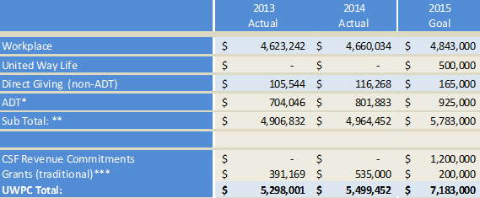
*ADT total includes Russell Family Foundation. 2015 Represents 15% growth
**Backed out ADT WP from subtotal to not duplicate WP and WP ADT. This is $650,000 in 2015 Goal
*** Grants in 2014 included First 5 Fundamentals ($300K) which is now independent

Campaign Goals by Donor Segment
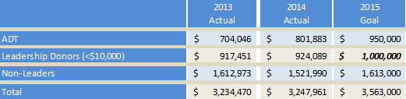

Key Goals:
* ADT: Move from 29 to 40 members
** Leadership Donors: Grow from 546 to 660 Donors. (Includes reducing churn by 10%)
114 Additional leadership donors include goal to gain 50 WLC members (200 in 2014)

2015-16 Community Campaign Goal Tactics - Individual Donor Engagement (IDE):
Last Year
    - 523 Leadership donors to 546 in 2014. But only grew $6,638 in leadership donor revenue
    - Thanked All Donors over $200
    - Built out ROI piece and Bubble Story Piece Donors
    - Focus – Corporate Engagement (Volunteerism/Tours with Company)
This Year:
    - Identified 24 Top Tier Accounts (Based on Churn & Revenue)
  - Represent 3,958 donors & $1,971,000. Accounted for $273,000 in Churn.
    - Build Year Round Communication Plan with Donors not the Company (but aligned w/ campaign dates)
  - Mapped out Quarterly
  - Best Practices Model -Storytelling/ROI/THANK YOU {Example: Twin Cities and Paul/CANDO)
    - Pre-Campaign Telethons (3 Scheduled through October)
  - Exp. Spring Telethon for Pre-leadership
    - Pipeline 450 Individual Donors assigned to RD Staff
    - WLC/EPP
    - CEO Calls: 85 annual. 40 met/scheduled by Sept 30th. 27 currently.

Preleadership telethon: Were able to contact 219 of our 281 leadership donors of spring campaigns. Group worth $239,408. Efforts retained 77% of donors and 85% of the dollars ($203K). Churn was 26% less for those called then rate for leadership donors overall.

WLC: Goal is 50 more donors (200 to 250); Identification of adopted issue
EPP: Goal is 5 visits/contacts prospects a month – revised the pledge form to identify more. Go from 20 identified EPP members to 60. (Council grown from 3 to 9 in past 6 months)

2015-16 Tactics: Look Back at Direct Giving
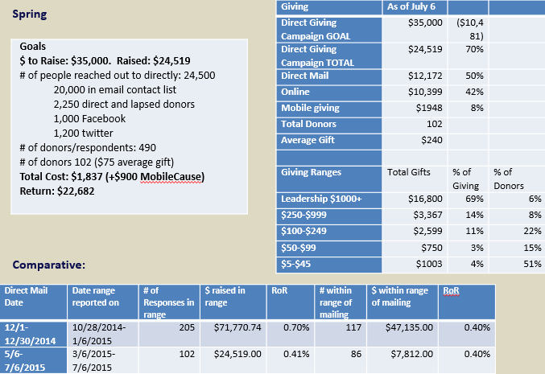
Lessons Learned: Response rates better when clear product. Summer Giving is slower in industry so push up to April time period. Add engagement component as did with 2-1-1.
*Since this Report recouped an additional $800 in mobile giving pledges. So actual figure is $2748.
*Looking at Hunger Initiative for End Year (children focus) – Early communications in Sept will align to build foundation.

Rick Meeder talked about the Dare to Care Strategy for this year’s Day of Caring.
- Participate in Day of Caring on Friday, Sept. 18th - either as an individual or by rallying a team at your workplace,
- Donate a backpack with school supplies to the Back to School effort,
- Or post a photo or video on social media of you doing good in your community and extend the Dare to Care to three people.
- Remember to tag United Way of Pierce County and use the hashtag #DareToCare.

Rescue Mission
Kari Young, Donor Relations/Major Gifts Officer for the Rescue Mission gave a brief overview of the work the Recuse mission does.

Adjourn
Jamey adjourned the meeting at 9:30am

