Jamey McCormick, Presiding

MINUTES

Executive Committee Members
Jamey McCormick | Matt Levi | Kent Roberts | Jo Anne Coy
Linda Nguyen | Jennifer Nino | Rick Meeder | Patty Rose
UWPC Staff: Dona Ponepinto, Sean Armentrout, Heidi Hansen
Call to Order/Welcome
Jamey called the meeting to order at 7:30am

Approve Minutes from June 17, 2015
M/S/C

Finance
The finance report was sent in the packet. This is a read only report this month.

Governance
Linda gave a report on the Governance Committee. At the last meeting we talking about Board recruitment and the leadership competencies needed on the board. A survey was sent to board members asking for their strengths and competencies. We haven’t talked about specific individuals in depth. The committee is determining additional things that are important to consider as we look at bringing on new board members. They are also working on updating the Board Goals and dashboard.

Planned Parenthood Update
We have had a few calls/emails (no donors). No United Way funds Planned Parenthood abortions, those that do receive funds are for programs for health clinic and education. We have received some donations designated to Planned Parenthood. This has been an opportunity to say what we do.

2015 Campaign – Strategies for Success
Sean gave an update on the campaign.

Campaign Goals
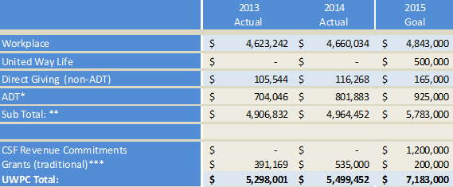

*ADT total includes Russell Family Foundation. 2015 Represents 15% growth
**Backed out ADT WP from subtotal to not duplicate WP and WP ADT. This is $650,000 in 2015 Goal
*** Grants in 2014 included First 5 Fundamentals ($300K) which is now independent

Campaign Goals by Donor Segment
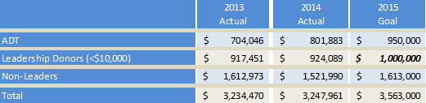

Key Goals:
* ADT: Move from 29 to 40 members
** Leadership Donors: Grow from 546 to 660 Donors. (Includes reducing churn by 10%)
114 Additional leadership donors include goal to gain 50 WLC members (200 in 2014)

2015-16 Community Campaign Goal Tactics - Individual Donor Engagement (IDE):
Last Year
    - 523 Leadership donors to 546 in 2014. But only grew $6,638 in leadership donor revenue
    - Thanked All Donors over $200
    - Built out ROI piece and Bubble Story Piece Donors
    - Focus – Corporate Engagement (Volunteerism/Tours with Company)
This Year:
    - Identified 24 Top Tier Accounts (Based on Churn & Revenue)
  - Represent 3,958 donors & $1,971,000. Accounted for $273,000 in Churn.
    - Build Year Round Communication Plan with Donors not the Company (but aligned w/ campaign dates)
      - Mapped out Quarterly
      - Best Practices Model -Storytelling/ROI/THANK YOU {Example: Twin Cities and Paul/CANDO)
    - Pre-Campaign Telethons (3 Scheduled through October)
      - Exp. Spring Telethon for Pre-leadership
    - Pipeline 450 Individual Donors assigned to RD Staff
    - WLC/EPP
    - CEO Calls: 85 annual. 40 met/scheduled by Sept 30th. 27 currently.

Preleadership telethon: Were able to contact 219 of our 281 leadership donors of spring campaigns. Group worth $239,408. Efforts retained 77% of donors and 85% of the dollars ($203K). Churn was 26% less for those called then rate for leadership donors overall.

WLC: Goal is 50 more donors (200 to 250); Identification of adopted issue
EPP: Goal is 5 visits/contacts prospects a month – revised the pledge form to identify more. Go from 20 identified EPP members to 60. (Council grown from 3 to 9 in past 6 months)

2015-16 Tactics: Look Back at Direct Giving
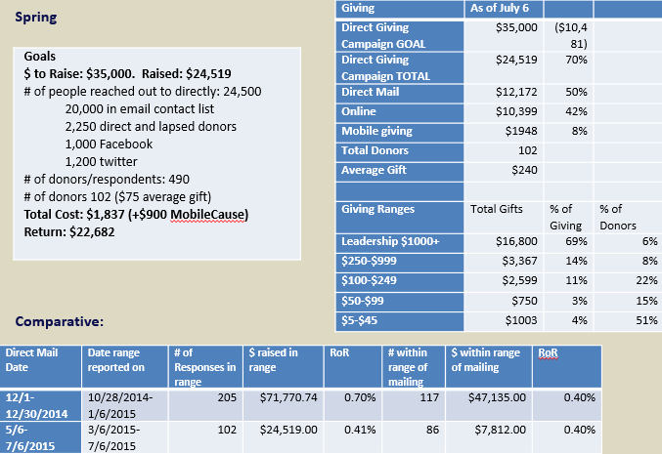
Lessons Learned: Response rates better when clear product. Summer Giving is slower in industry so push up to April time period. Add engagement component as did with 2-1-1.
*Since this Report recouped an additional $800 in mobile giving pledges. So actual figure is $2748.
*Looking at Hunger Initiative for End Year (children focus) – Early communications in Sept will align to build foundation.

Presidents Report
- Centers for Strong Families: We did not get the SIF grant, but still going forward and would like to have a Center going by December. Dona has spoken with the companies that had agree to put up money if we got the grant, requesting their continued support. Dona would like to go to the Board to seek support and approval to use the $100K (approved match) to support a CSF pilot. The committee requested Dona give an in-depth report to the Board.

- Staffing updates:
  - Sean Armentrout will be leaving mid-September to go back to school, he will work part-time through October. Mike Leonard will be interim VP until the position is filled.
  - Renee Ghan has left and Penni Belcher has been promoted to Call Center Manager.
  - Campaign Executives (6) will start August 24th.
  - UWPNW Staff and Volunteer Roundtable – September 23rd in Everett. Stacey Stewart, US President of UWW, will be the guest speaker. Also, there will be an in depth training/ preparation on ALICE Let us know if you would like to attend.

Adjourn
Jamey adjourned at 9:08am

