May 20, 2015 United Way of Pierce County
7:30am – 9:00am 1501 Pacific Avenue, 4th floor

Jamey McCormick, Presiding

MINUTES

Executive Committee Members
Jamey McCormick | Jennifer Nino | Jeffrey Vernor (C) | Jo Anne Coy
Linda Nguyen | Debi Young | Rick Meeder
Matt Levi | Kent Roberts | Patty Rose
UWPC Staff: Dona Ponepinto, Pete Grignon, Sean Armentrout, Lindsay Tracy, Ted Smith, Aimee Collins, Heidi Hansen
Guests: Lauren Anderson, Liane Williams, Mike McCrabb, Elizabeth Bailey (call)
Call to Order/Welcome
Jamey called the meeting to order at 7:30am

Jamey welcomed our auditors and members of the Finance Committee.

Approve Minutes from April 22, 2015
M/S/C

Finance
Pete introduced Lauren Anderson and Liane Williams, our auditors from McGladrey. They gave the 2014 financial audit report. As of the end of April 2015 United Way of Pierce County (UWPC) completed its audit of the 2014 financial statements. We received an unmodified, “clean” opinion. Simply, this means United Way’s financial statements are fairly presented in all material respects.
Assets
- Cash increased in 2014 by approximately $352,000 due to the increase in the investments and controlling expenditures.
- Total investments increased by $431,000 in 2014, which was driven mostly by market appreciation and additional purchases of investment securities
Liabilities and Net Assets
- Accounts payable and accrued expenses and grant payable decreased by approximately $26,000 which was largely the result of changes in the grant payable stemming from the 2014 scheduled payment to the Boys & Girls Club.
- Agency funds payable decreased by $16,000. This fluctuation is attributable to certain donor designated gifts received as part of the current campaign that were requested to be paid out prior to the end of 2014.
- Temporarily restricted net assets increased in 2014 by approximately $445,000. This fluctuation was a result of an increase of grant income. Unrestricted net assets also increased to a lesser degree, and there were no changes in permanently restricted net assets.
Revenues
- Total '13-'14 campaign results are up more than $88,000 when compared to the prior campaign ('12-'13). This increase was primarily to do the increase temporarily restricted revenue (grants) received in 2014.
- Total '14-'15 campaign revenue thus far are up approximately $98,000 over '13-'14 campaign during the same period. The increase is largely attributable to certain campaigns running in the fall when they had run in the spring in the prior year.
- Donor designations for the '13-'14 campaign increased by approximately $129,000, which is consistent with the decline in that year's campaign revenue. Donor designations for the '14-'15 campaign decreased approximately $280,000, which is mostly attributable to the increase in that campaign's revenue thus far.
- The other significant change can be seen in the $317,000 decrease in Other Income resulting from a decrease in in-kind advertising and donations.
Expenses by Category
- Funds allocated to agencies reflect payouts approved by the Board as a part of the approved 3-year payment cycle, net of amounts designated by donors. The decrease of approximately $800,000 over the prior year stems from consistent portion of campaign revenue being designated by the donor, as well as a $300,000 reduction in funded agencies in the new investment cycle.
- Community program service expenses decreased by approximately $282,000 due to savings from an organizational realignment.
Functional Expenses
- Salaries and related benefits decreased approximately $171,000 due mostly to the previously mentioned organizational realignment.
- In-kind expenses decreased approximately $161,000 stemming from a decrease in gifts in-kind distributed to community nonprofits.
Cash Flows
- Cash flows from operating activities resulted in net cash provided by operating activities of approximately $831,000. This net cash inflow was due to decreases in cash used for payroll related costs and distributions to agencies. These decreases, coupled with consistent contributions coming in the door resulted in a net cash inflow in 2014. Cash used in operating activities in 2013 was approximately $1,320,000.
- Cash flows from investing activities resulted in a net cash used in investing activities of approximately $376,000, which was directly a result of investment purchases outpacing investment sales in 2014. Cash used in investing activities was approximately $438,000 in 2013.
- Cash flows from financing activities resulted in a net cash outflow of approximately $100,000 in 2014, which is consistent with the cash outflow in 2013 of $100,000. This activity is comprised of payments made to the Boys & Girls Club as part of the grant agreement.

There were two major reasons why our community investments were significantly different from 2013 to 2014.

- Funding from prior year reserves in donor designated impact areas; a much smaller amount from board set aside impact funds
- New investment cycle funding dropping from $1.5M to $1.3M

Coming out of the great recession, from 2011-2013, we had some reserve match money from the departure of Russell Investments. The board voted to use that money over the 2011-2013 funding cycle which allowed for a greater investment in community agencies. In the current investment cycle, we couldn’t sustain that amount as it had been used up. We forecasted that we would invest $1.2M a year for 2014-2016; a $300,000 difference.

Campaign
Sean thanked Linda Nguyen for inviting Eric Hahn to the CLC and the Community Celebration. After that he went to his board at General Plastics and they donated $20,000 to UWPC.

How do we get the Board more engaged in fundraising? It was suggested that Board Members have a stretch goal of $10,000 ($400 each) that they try to raise. We need to tap into our connections. The Board needs educated to be ambassadors for UWPC.

Campaign Goals by Revenue Stream (As of May 18, 2015)
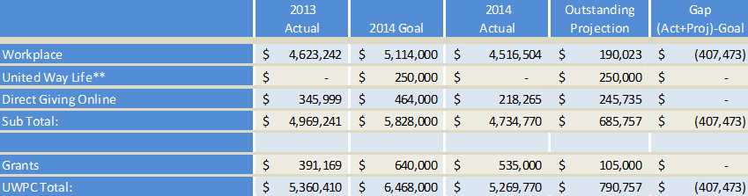
2013 Numbers--Used Actuals: Workplace is Total in Enterprise less CRD and Direct
2014 Total--$925,000 ADT Goal is split $611,000 to Workplace and $314,000 to Direct
Closing the Gap: Campaigns closed but unaudited $80,017 and another $17,600 projected for campaigns currently running through May 8. Total - $97,617

Campaign Goals by Donor Segment (As of May 18, 2015)
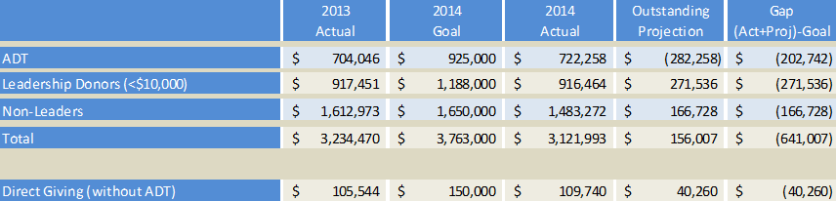
Closing the Gap: Campaigns closed but unaudited $80,017 and another $17,600 projected for campaigns currently running through May 8. Total - $97,617

Closing the Gap
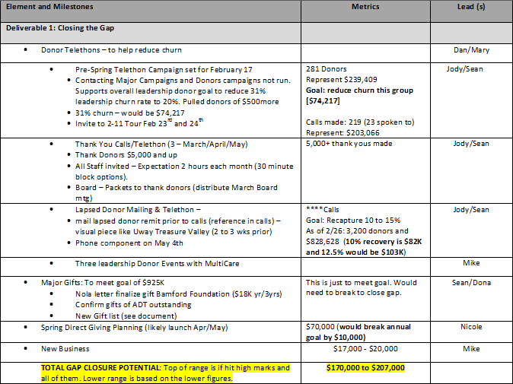

Aimee explained United Way’s Summer Learning Initiative, which is a partnership with Graduate Tacoma, Metro Parks, Boys & Girls Clubs of South Puget Sound and local schools. The Summer Learning Initiative is focused on stopping the ‘summer slide’ by providing access to opportunities for supplemental learning and reading activities over the summer.

Focus: Summer Learning Initiative
- The Summer Learning Initiative is focused on stopping the ‘summer slide’ by providing access to opportunities for supplemental learning and reading activities over the summer. Components of the initiative include:
  - Summer Learning Every Child website – featuring opportunities across Pierce County in one easy to use website for parents
  - Summer Learning Project with summer meal sites – providing weekly enrichment and reading activities for children being served by free summer meal sites
  - Little Free Libraries project, where volunteers will build, decorate, install and fill Little Free Libraries in neighborhoods around two high-need schools—giving kids access to books throughout the summer

Kids without access to summer enrichment programs lose more than two months in reading achievement. By the end of fifth grade, this may add up to nearly three grade equivalents. Your donation makes enrichment programs more accessible to kids throughout Pierce County and makes a “summer slide” fun again.

Fundraising & Marketing Mechanisms
Public Relations: Exit133, Business Examiner and Tribune
Direct Mail: 1 letter, 2,200 letters total
Direct Email: 81,840 emails, 20% Average open
Videos: Tutors, parent/child, Prairie Ridge piece & educator testimonials
Blog Articles: Two blogs from different perspectives.
Social Media: Twitter and Facebook included daily posts & crowdfunding

Crowdfunding
Aimee explained Mobile Cause, which is what we used at the Celebrate Community event. It takes less 4 minutes to set up a personal fundraiser page. We are just starting on this, but definitely something staff and Board and use. We need to get the Marketing Committee involved also.
- Crowdfunding is the practice of funding a project or venture by raising monetary contributions from a large number of people, typically via the internet. One early-stage equity expert described it as “the practice of raising funds from two or more people over the internet towards a common Service, Project, Product, Investment, Cause, and Experience, or SPPICE.”
- The crowdfunding model is fueled by three types of actors: the project initiator who proposes the idea and/or project to be funded; individuals or groups who support the idea; and a moderating organization (the "platform") that brings the parties together to launch the idea.
- In 2013, the crowdfunding industry grew to be over $5.1 billion worldwide.
- https://app.mobilecause.com/vf/Summer2015

Presidents Report
- Organizational Assessment/Goals – Looking at what needs to improve based on the results. Working in 3 area: Revenue, Relationships, and Impact. At the end of the campaign we will be evaluating what worked/didn’t work. One thing to work on is donor churn. The Campaign Cabinet will be meeting soon, we have 7 members at this time, and we will get their input. How do we become the donor of choice? Centers for Stronger will be a big initiative.
- SIF Grant – Dona introduced Lindsay Morgan Tracy, our new Vice President of Community Impact & Engagement. Lindsay work on the grant as a consultant before being hire. We made it to the second round. We are staying very positive and working on this.
- Advocacy Updates - Legislative is still pending on 2-1-1, Helen is at the Capital weekly and working with Statewide 2-1-1 to get the message out. We are working on a Plan B, if it becomes necessary.
- Dues Structure Update – Dona is on the steering committee, working with UWW. This increase will have a significant effect on some UW’s.
- Prairie Line Trail – The city will be purchasing the property and hopefully complete the project this summer.
- Celebrate Community Event – The event was very successful. This year it was a breakfast and had a Rich Harwood as a keynote speaker.

Executive Session
Staff was excused for the executive session.

Adjourn
Jamey adjourned at 8:55am

